AI Use Declaration Form
Course: Introduction to Artificial Intelligence
Lab Title: Lab 1 Part A — Uninformed Search Algorithms
Student Name: __Monia Nijimbere_________________________________________________
Student ID: _67912028_____________________________________________________
GitHub Repository Link: ___________________________________________
Date Submitted: __Le 05/06/2026________________________________________________

1. AI Use Summary
Question | Student Response
Did you use any AI tool for this lab? | Yes
Estimated percentage of the work influenced by AI | 15 %
Did you attach evidence of AI use where applicable? | Yes

2. Details of AI Use
Complete the table below for each AI tool used. Add more rows where necessary.
Name of AI Tool Used | Purpose for Using the Tool | Prompt or Instruction Given to the Tool | Part(s) of the Work Influenced by the Tool | How I Verified, Edited, or Improved the AI Output
Chatgpt | To understand the task which is expected to be done and guidance | What does def. Do?  How do we fill missing values in our tables?  How do we plot? | Ploting part  Missing values | I double checked what I was asked for to see if actually what chatting is saying make sense

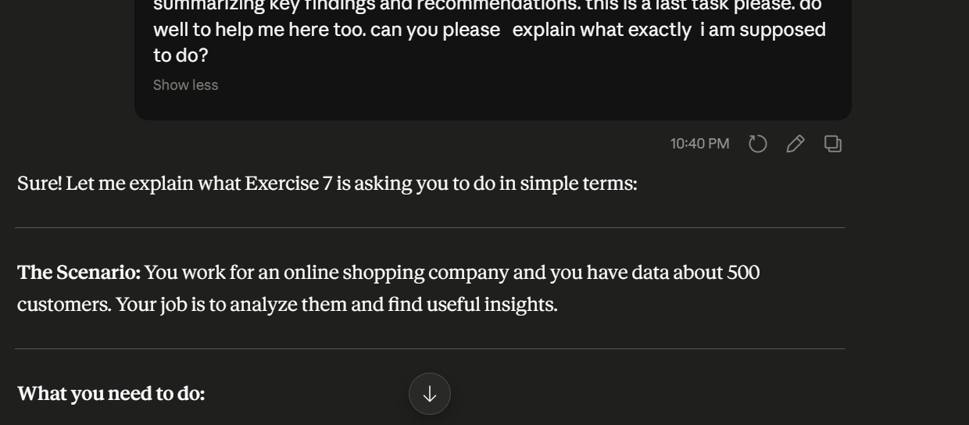
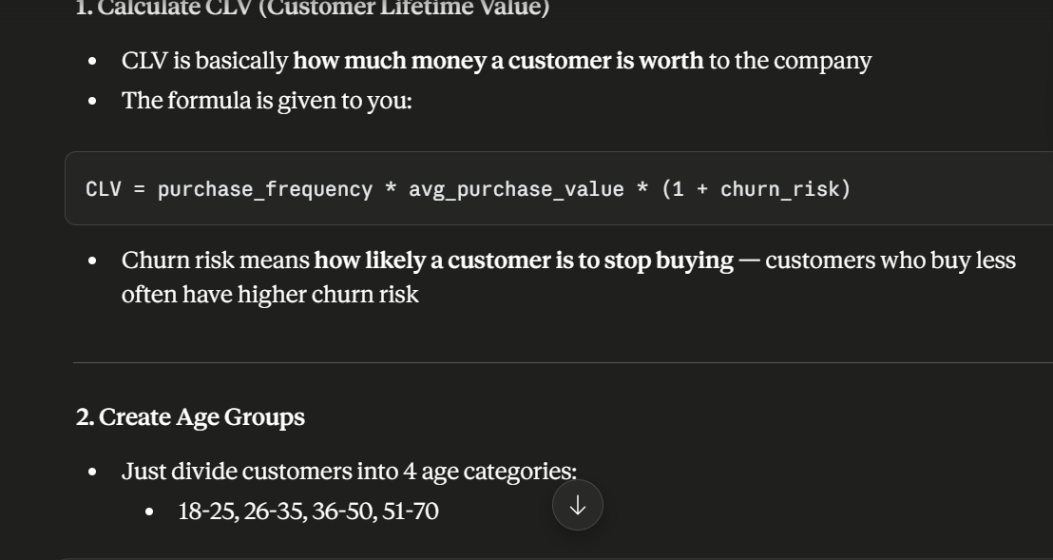
3. Attachment of AI Output Evidence
Where required, attach evidence of AI use. Tick all that apply. Add more rows where necessary.
Evidence Type | Attached? (Yes, No, N/A) | File Name
AI-generated draft | Y
Prompt history | Y
Screenshot of AI interaction | Y
Exported AI conversation | N/A
AI-generated code snippet | Y
Revised version showing student input

4. Student Declaration
I declare that:
Declaration Statement | Response (Yes/No)
The submitted work is my own work. | Yes
Any use of AI tools has been clearly declared in this form. | Yes
The prompts, instructions, and AI-generated outputs have been disclosed where applicable. | Yes
I reviewed, tested, edited, and improved any AI-generated content before submission. | Yes
My AI usage does not exceed 25% of the entire work. | Yes
I understand that undeclared or excessive AI use may be treated as academic misconduct. | Yes

Student Signature: ___Monia Nijimbere________________________________________
Date: __05/06/2026_________________________________________

